NOTE TO EDITORS
Please claim a font color and make sure anything you add is in that color for easy crediting.

Valentine: Black
Rayburn: Mustard
GuestIsJustBest: Blue

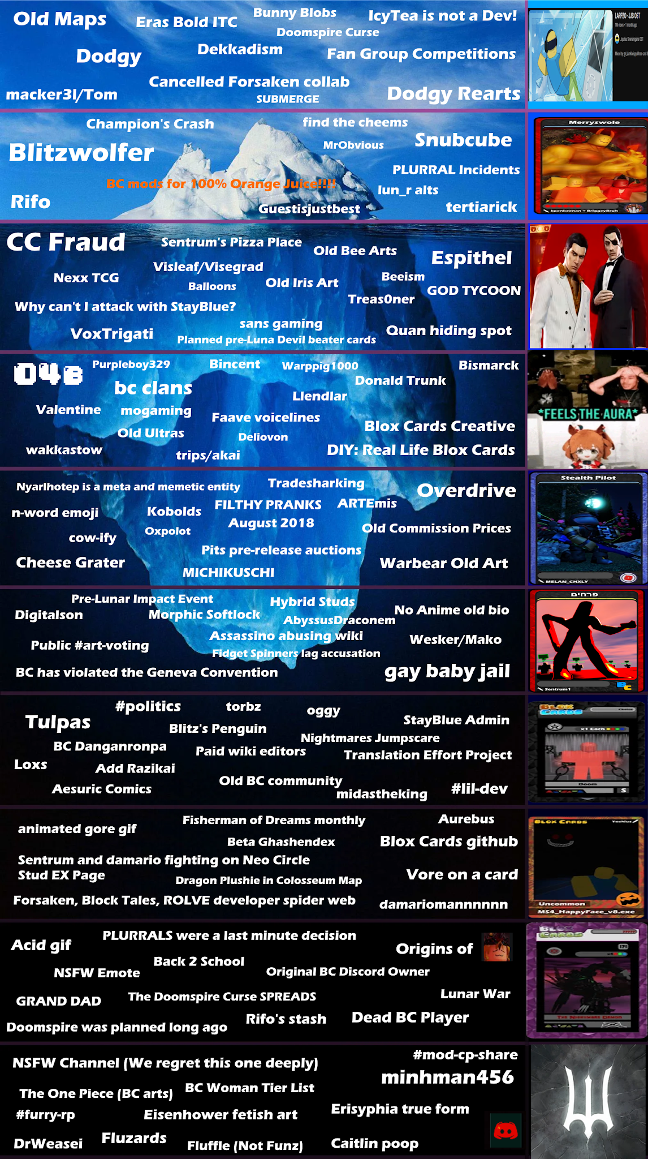

TIER 1
- Old Maps: Periodically the Blox Cards map will change as the game develops. I do not know how many maps were used in total but there has been a few different ones.

- Eras Bold ITC: The name of the font used on Lunar cards. Lunar being the name of the current format Blox Cards are made with.

- Bunny Blobs: A little creature that is a reference to the original coder of the game Visleaf, who’s sona is a rabbit.

- “IcyTea is not a Dev!”: A unfunny meme centered around the fact IcyTea is not actually a developer. Moreso a Director. He does not code games; only hires people to develop his ideas.

- Dodgy: A Euphemism for pedophile or otherwise sexually deviant person. Blox Cards has a lot of individuals like this over the years that we’ll get into later in the tierlist.

- Dekkadism: Dekkadism is a cancelled ARG made by Hypns pretty sure

- Doomspire Curse: Almost everyone who worked on doomspire had something horrible happen to them, including but not limited to
  - Hurricane
  - Car Accident
  - Power outage
  - Close family dying
  - Close family almost dying
  - Cancer
  - Computers violently exploding
  - Almost dying
  - Almost killing themselves
  - Getting hacked
  - Flooding
  - Being sexually assaulted
  - Sending NSFW to people under the age of 18

- Fan Group Competitions: Very rarely, Blox Cards will have a contest where people pair up in teams to create a Blox Cards group that will be added to the game. One example of a winning group is the Wanwood Forest Pixies.

- Mackerel/Tom: A prominent artist and member of the community. Creator of Iris. Was banned for a brief period for what was basically just him being kind of a jerk but is unbanned now. Nope he’s still banned in main pretty sure

- Cancelled Forsaken Collab: So blox cards was going to collab with forsaken but then developers were shitty and we cancelled it, and then new developers happened and the collab was back except it wasn’t and fhiuaofisaojdiaojioifa it was soooo confusing https://docs.google.com/spreadsheets/d/1XStxAMClZDcwGMdhwpc4jdZAK6SvWZ8xzSCU1zKhMgQ/edit?gid=438687074#gid=438687074

- Submerge: Weird arg made by Azizapat and Flat pretty sure, one for them

- Dodgy Rearts: Blox Cards has a policy where they re-art things made by creators they consider “dodgy”. This proves to be a Herculean task when your artist, particularly some of your biggest artist, are constantly being outed for such. Such is life for a Roblox game. 🤧

TIER 2

- Blitzwolfer: THE OG Artist of Blox Cards. Like. Not an exaggeration the very first Blox Cards 2D artist and a huge foundation for the game and how they handle arts. Is still somewhat active online under the name AntArtist.

- Champion’s Crash: Really old FTK where if you killed yourself turn 1 the game would crash immediately

- Find The Cheems: Find the chomiks if it was good

- MrObvious: A notorious Roblox Pedophile who played Blox Cards once and used to be in the game. Removed now, obviously.

- Snubcube: A formerly prominent artist for BC. Banned for being inappropriate with a minor (The details I’m a bit fuzzy on though so someone else can fill that in I guess). Currently inactive online. Ok - Rayburn

- Rifo: Ah how the mighty have fallen. Rifo was THE Blox Cards artist for a non-insignificant amount of time. Carried the back of the Zombie Stories expansion after I had to step down. Created many BC OCs that are in the game. Made the art for probably close to like 50 or so cards. He was banned initially for just being kind of a jerk, but then they did some digging and found he engaged in a lot of innapropiate behavior including sending NSFW to someone underage, drawing NSFW while underage and being racist to name a few things. Currently inactive online.

- BC Mods for 100% Orange Juice: Me and Sentrum made mods for 100% OJ use them I like them please https://steamcommunity.com/sharedfiles/filedetails/?id=3469009442

- Lun_R Alts: Lun_R was an artist back in the early days of BC who’s alt arts used to be considered the cream of the crop. Nowadays I don’t believe he even does arts anymore, but his art was very popular back then and it’s not hard to see why.

- Guestisjustbest: Who is this guy?

- Tertiarick: A former BC Artist and moderator who was known for having stupidly strict ideas on how art should be when his own art was… kinda mid. Hey that’s according to the others I’m just saying. Got banned for Credit Card fraud (Which will be elaborated on later in the list) and I’m not sure if he was ever unbanned for this.

- Plurral Incidents: So what happens when you make a faction all about mentally ill catgirls that party all the time and put all of their stans into one channel, you get every other faction channel deleted. #Plurral had like ⅓ Ratio of Dodgy to not dodgy, while some cases in my opinion were a tad bit of an overreaction, the channel is notorious for being infested with these people

TIER 3
- CC Fraud: An event where someone shared a credit card number that was posted online and a LOT of prominent users used this number to buy Robux and other stuff. Tertiarick, Fut_re and Arte71 are three I remember getting temp banned for this, the first two being mods.

- Sentrum’s Pizza Place: A location on the old map. I think it was in a in-joke war against a pizza place run by Blitzwolfer.

- Old Bee Arts: The bees in the game used to be regular, original models of bees. Replaced by Bee Swarm Simulator bees.

- Beeism: A user that rhymed with Teaism. The two cards were meant to be played together in a deck. The Beeism card has since been replaced with Soulful.

- Attacking with StayBlue: StayBlue is a card that cannot attack. The card bio is a joke about people not reading the card effect.

- VoxTrigati: A Roblox user who happens to also be a card in the game, added a long time ago. The user’s username has changed since then. Vox was I think banned for being a porn artist, sneaking porn into the game and trying to steal BC’s code.

- Treas0ner: An old user and artist who was bullied HEAVILY in the server for being autistic. Developed alters and tulpas to cope with the immense amount of bullying he went through. Deserves to be left alone.

TIER 4
- DIY Real Life Blox Cards: Refers to an old video tutorial about how to print out the game cards on paper.

- Old Ultras: Ultras used to have different gameplay that took away the user’s colored studs instead of requiring a terrain card.

- Faave voicelines: Refers to old voices in the game to announce when you got rare cards from a pack. These were changed to the voice of a different user. The reason for this is because Faave got accusations of grooming put out. Unsure if these were ever confirmed to be true.

- 04B: The name of the font used in the Blox Cards logo

- Blox Cards Creative: A server I made when BC was very toxic to artist as a place for the artist to gather (Sadly the community’s toxicity did not leave when they came over). Has been boogeymanned to death by people who weren’t even in the server. No longer active.

- PurpleBoy329: An old user who’s entire gimmick was bragging about his porn addiction and having cropped Pokemon Porn icons. He had his dog in the game at one point and has his own card ig but other than that im not sure he ever really contributed anything. Still active online as a decently popular YouTuber.

- Bincent:

- Warppig1000: An old user who was known for being REALLY eccentric but as far as I know harmless.

- Donald Trunk:

- Bismarck: A old user who was a massive gooner. Responsible for the infamous Stripper Art scandal and in general got a lot of really sussy, sexual arts in the game back when moderation was awful.

- Valentine: Me, ActualTsareena. A former artist for the game and a BC OG that is still kind of around. The Eisenhower lover. Probably infamous for my formerly untreated Bipolar episodes, making BCC, and having an abusive relationship with BC and its community.

TIER 5
- August 2018: A month that was used when joking that something would never happen.
- Oxpolot: Old card artist. Used to have a forced meme with Wooloo Gaming which spawned a bunch of other “gaming” clans. Not sure what he’s up to nowadays.
- Cheese Grater: May refer to the cheese graters on the Profane Cheese Shredder card, which has since been replaced. Was also an inside joke in the old days of BC referring to the infamous art of the Furaffinity mascot and the cheese grater.
- Michikuschi: EndlessCactuar. A former mod. Banned for… reasons I don’t want to say. Sorry, it’s still a bit of a sore spot. 🤧Still active in other communities and is a better person now though.
TIER 6
- Fidget spinners lag accusation: Some users blamed fidget spinner tools for lag in the game. Some of the old maps had places to pick up these fidget spinners. The fidget spinners have since been removed from the game.
- Wesker/Mako: Perhaps the most infamous old moderator and was at one point a co-owner of the server with AntArtist and Leaficarus. Was known for being kind of really a jerk and was eventually banned for confronting Myrm about potentially protecting a nazi (Visleaf) rather aggressively. In Mako’s defense tho Myr did used to “joke” and talk about Visleaf being antisemitic a lot. To this day it is unclear if these rumors are true or not. Still active but kinda on the down low these days (And is a lot better of a person nowadays)

- Digitalson: A former BC contributor. Protogen Furry. Was banned for essentially grooming another user with weird hypnosis shit.

TIER 7
- Midastheking: Refers to an old user who was the old version of the Rawblocky card. Iirc this user was known for being very uhhhh complicated with his commissions and is the reason certain rules are or were in place for what you can commission.
- Torbz: An old card artist.

- Nightmares jumpscare: Refers to a jumpscare that can appear when playing nightmare cards. Got removed due to health concerns

- BC Danganronpa: A fanfiction I was writing in the old days of BC Discord that put the active users at the time into a killing game. Here is some art I made for it
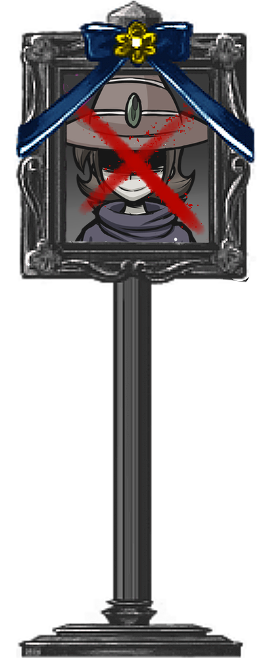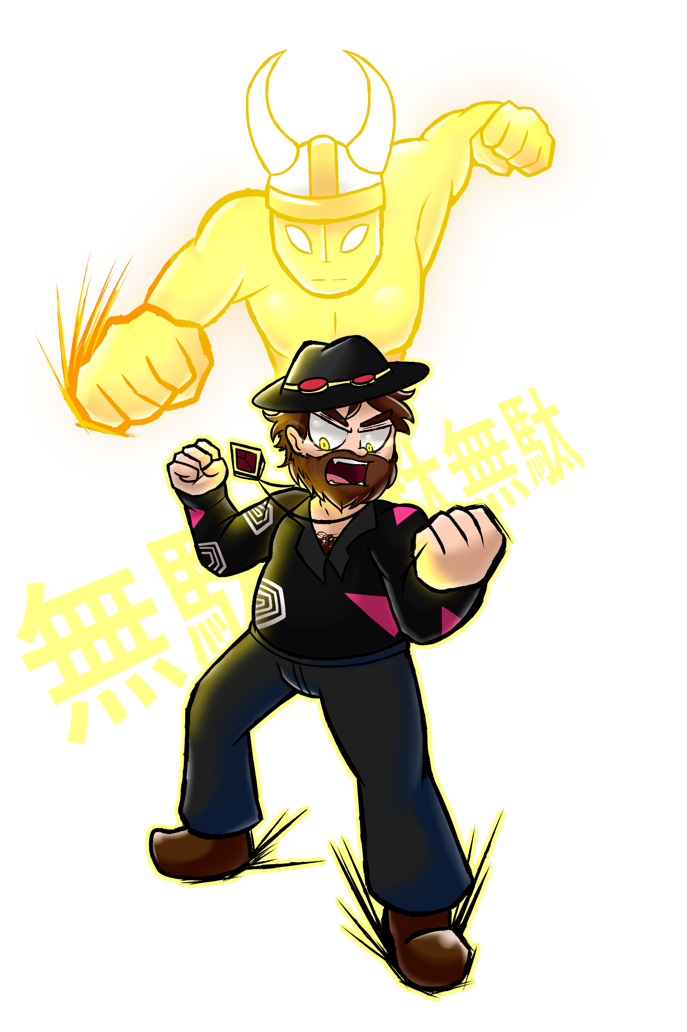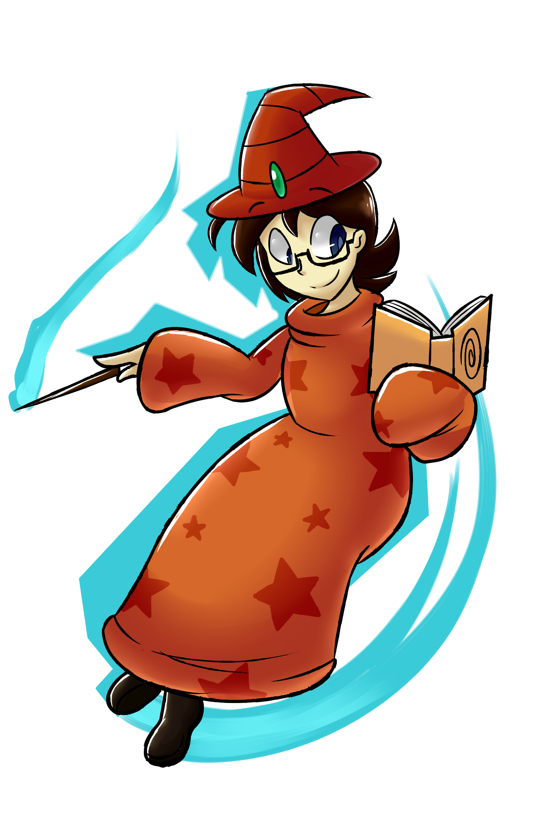

TIER 8
- Blox Cards GitHub: This repository was once used to keep track of card changes. The repository is owned by Visleaf.

- Fighting on Neo Circle Stud page: Refers to a wiki edit war that took place in 2020 over exaggerated wording on the page.

- Aurebus: A former artist for BC. Not sure why she is this low as she hasn’t done anything wrong or dodgy. She is still active online but won’t mention the user as her accounts are NSFW.
- Animated Gore Gif: Might be referring to when LeetLeeper posted a gif of JFK’s assassination for… some reason???

TIER 9
- GRAND DAD: Old version of iTrapped card. This was the character from the bootleg game 7 Grand Dad.

- NSFW Emote: Was an emote of the user PencilWizard and Lun_R’s avatars having (Undetailed) Roblox sex. Was used as a “Yeah!” reaction. Artistic Rendition here:
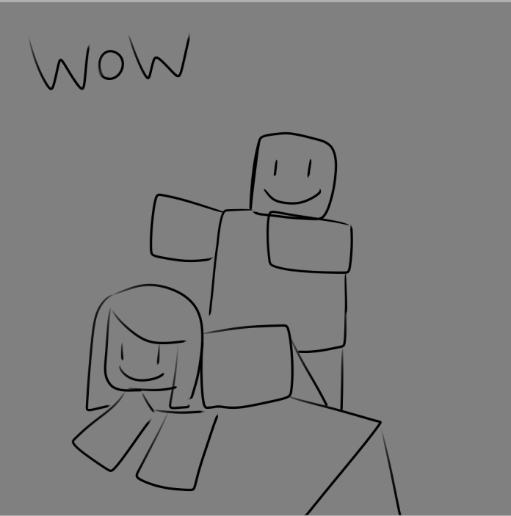

- Back 2 School: A failed event pack that Me, Aurebus, WDex, and SoulSearch were planning.

- Old BC Discord owner: Ok this story is so fucking funny and I’m sad not more people know about this. The old owner of the server was Inechi. Inechi was inactive for a loonngg time and Leaf, Ant, and Mako tried to get ownership from her and you know what she did? She really held the server hostage and offered to sell it for 13k robux LMAAOOOOOOO. I’m not sure if ownership was ever taken from her. I assume it is by now.
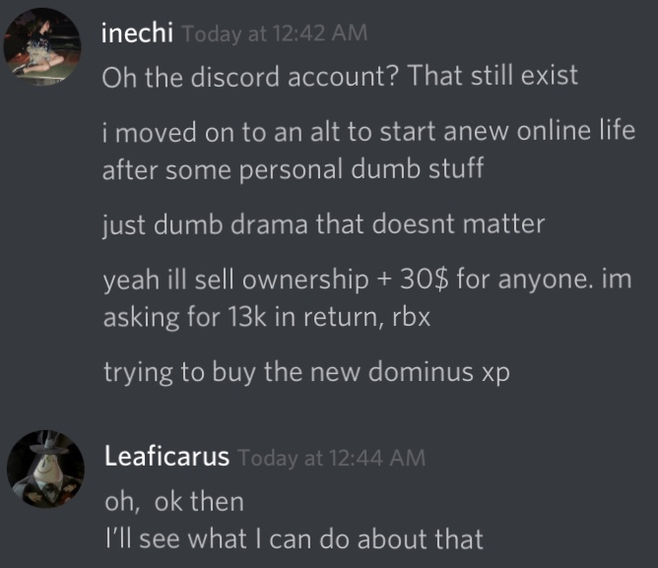

- Rifo’s Stash: Rifo has drawn a loooooottt of porn.

TIER 10
- Soviet Discord Icon: A private server owned by Sentrum that he treats like a huge secret when it is dead as hell and a big nothingburger. Oooh got you Sentrum the secret is out now 🤪🤪🤪🤪

- BC Woman Tierlist: There was two of these. One made by Blitzwolfer that was on the wiki and one made by Sentrum ranking all the female avatars in the game as waifus.

- Fluzards: An original species made by Myrm that sneeze jizz and are fluffy snakes. Idk man im so tired.

- NSFW Channel: Old BC literally had a NSFW channel.

- Fluffle (Not Funz): Possibly referring to Fluff/ICYRUBY. A furry porn artist that lurks in the community. Who ALSO APPARENTLY IS DODGY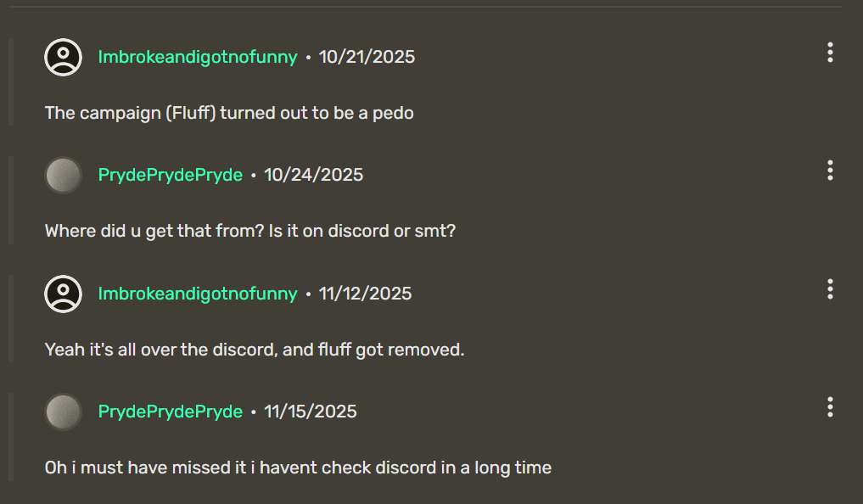

- Caitlin Poop: Probably the most cursed artwork Rifo has made. I won’t go into detail for your sanity.

- Eisenhower Fetish Art: I KNOW NOTHING.

- Erisyphia True Form: 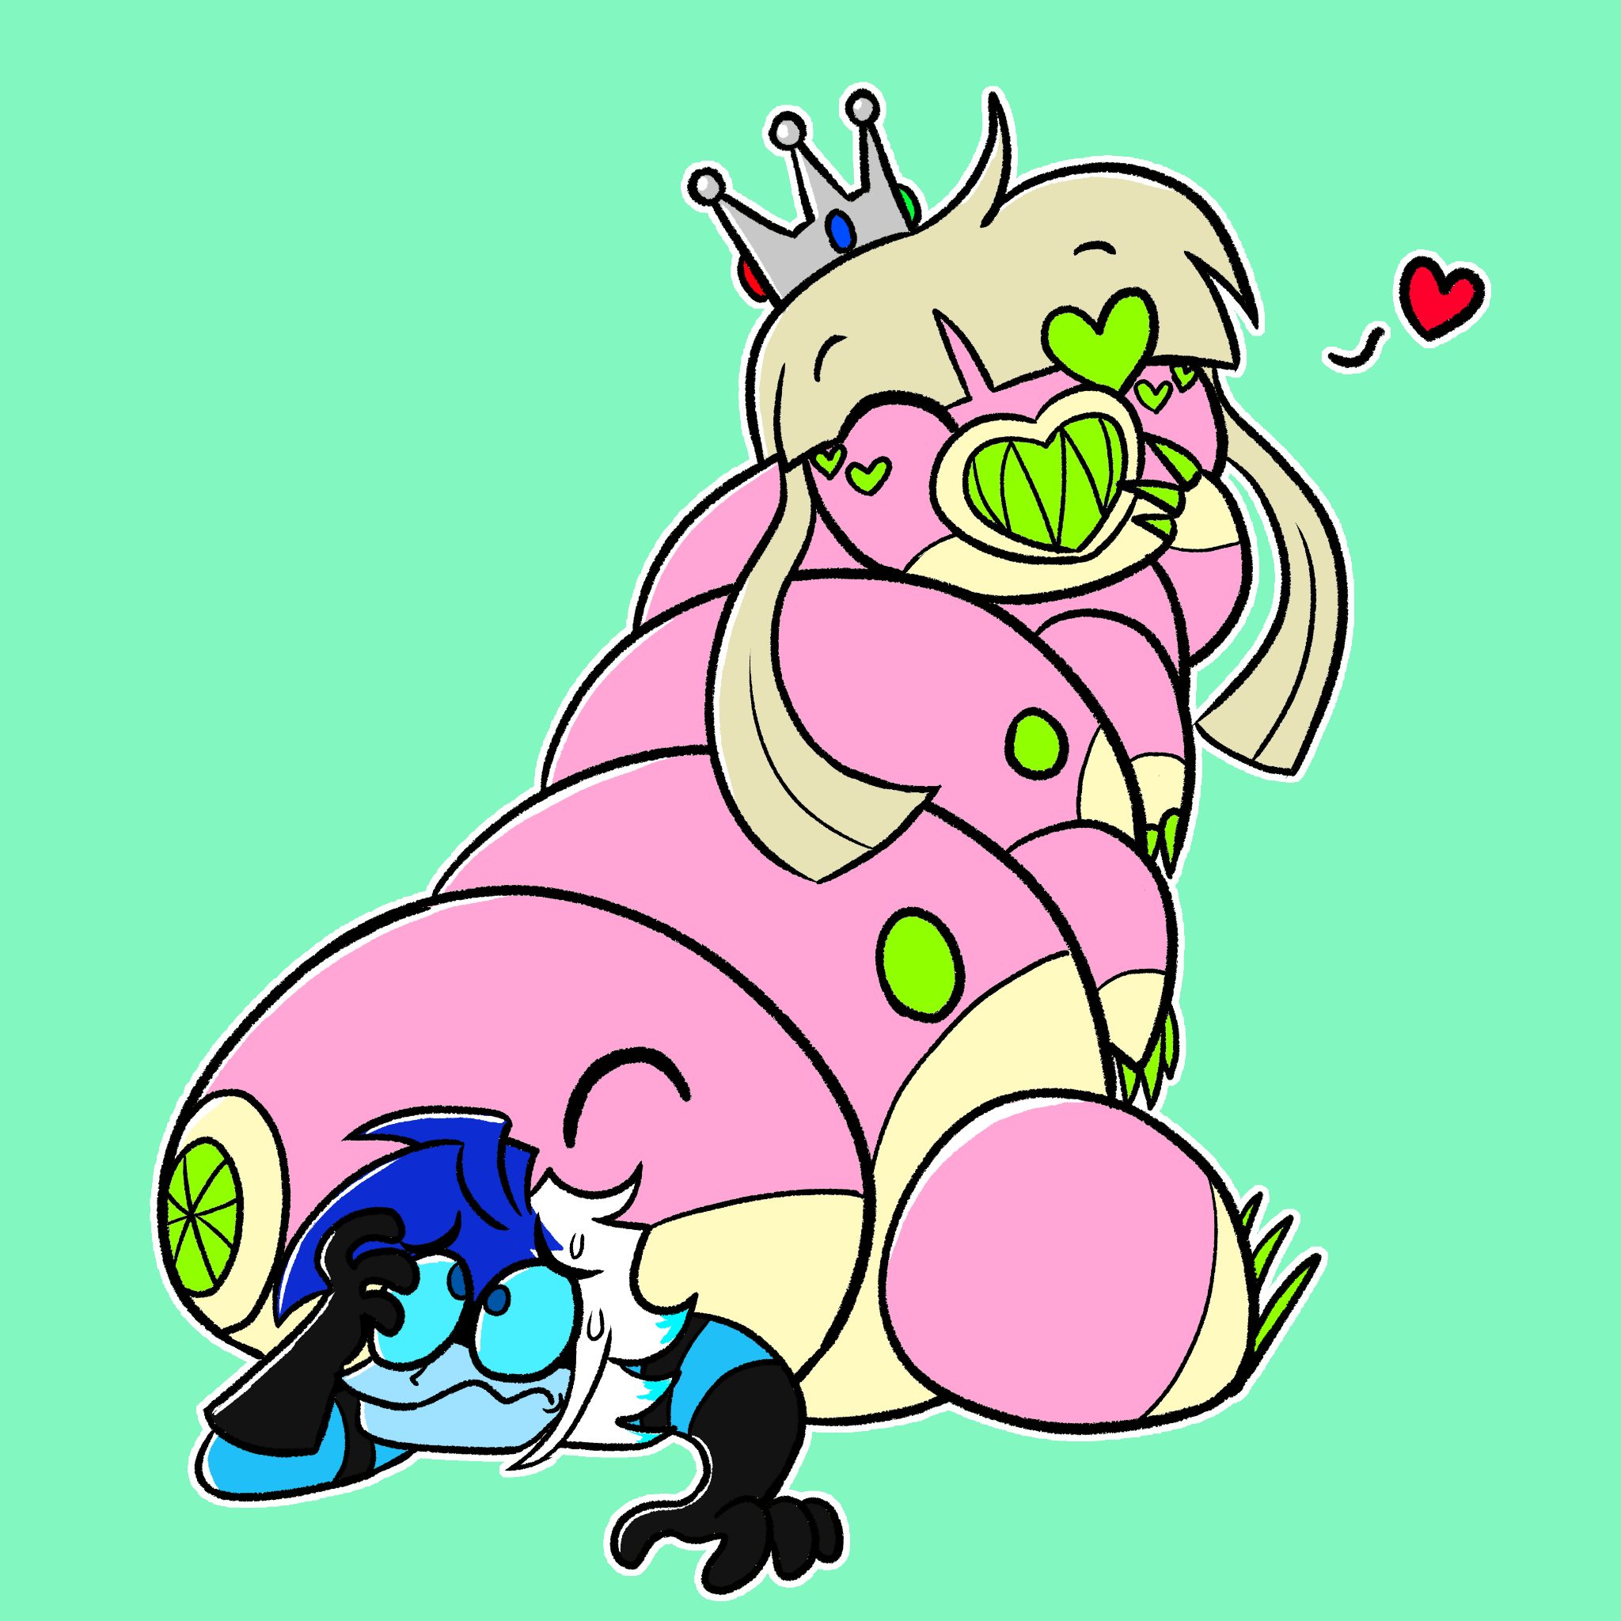 This is the one made by her designer (Me) but she also has a greater form that is not designed. Personally, I envisioned it as a massive hive of Anthrested forming a massive Eris Wishiwashi-style that kinda looks like Final Valgas from Power Stone. Oof Sorry I let my autism out. Are you sure this isn’t the fetish art

