Student Housing
Finding housing in a city you’re not familiar with can be a rough process. Hopefully the advice compiled here gives you a head-start.

On Campus
University Housing
For information on University Housing, visit
http://www.temple.edu/studentaffairs/housing/

Undergraduate _
University housing (dormatory) is reserved for Freshmen, Sophomores and Transfer students. Transfer students may apply for University housing beyond sophomore year.

Graduate _
On Campus
The University offers the following University housing options for graduate students:

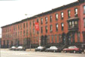Triangle Apartments / Houses
Broad and Norris Streets, Philadelphia
Triangle Apartments is located on Main Campus, which makes it convenient for students.
Rates range roughly $470 – $930 per month (as of 2007-2008) and include all utilities including electricity and cable TV. Furnished apartments and rooms are available.
Available per semester: Fall (August – December); Spring (January – May); Summer (June – July)

Off Campus
Podiatric Student Residence Complex
8th and Cherry Streets, Philadelphia
The Podiatric Complex is located within walking distance of nearly all of Center City. The Gallery at Market East Shopping Mall and Chinatown are only a block away, and Old City is just down the street. Temple offers a free shuttle during the Fall and Spring Semesters to and from the Podiatric Complex.
Rates range from $650 to $950 per month (as of 2007-2008) and include all utilities including electricity and cable TV.
All apartments are furnished.
Available per semester: Fall (August – December); Spring (January – May); Summer (June – July)
On-Campus (Not University Housing)
If you want to live on or close to campus and can not or do not want to take the University Housing option, I would recommend checking out these options and talking to Lisa Prestileo at the off campus housing office (see more below under “Resources”).

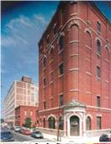
• Kardon-Atlantic Terminal (Philadelphia Management)
The Kardon building is located on the east side of campus. It consists of shared apartments with individual leases. The building itself is a converted warehouse, so the rooms are very large with high ceilings. Rates are comparable to University Housing, and I believe they include some utilities. Kardon is largely filled by Undergraduate students and is typically similar to the dorms in terms of noise.

• University Village
University Village is also on the east side of campus. It is just across the street from Kardon, and is similar in terms of rates, and arrangements. This building was just built in 2004 and is primarily filled by undergraduate students. I’ll warn that the walls are notoriously thin here, so sound carries moderately.

• Carlisle Street
The area immediately surrounding campus has limited reasonable options. The area bordered by Norris, 15th, Diamond, and Broad streets is arguably the only area within walking distance of campus that I would consider living in. This area is actually quite nice, but it is very small, so it is difficult to find an apartment or house here before it gets taken. If you want to stay on campus, take a walk around these houses and look for “For Rent” signs. I wouldn’t recommend even looking beyond those borders though.

• The Edge
The Edge is a new building just off of campus, which was built recently, in Summer, 2006 as part of a new shopping center complete with a new movie theater. The Edge got off to a rough start, with not having construction completed by the time the Fall, 2006 semester came up and students needed to move in. Soon after that there was a change of management and I haven’t heard much about it since. Try to talk to people before considering it. Like Kardon and University village it is full of undergraduates so it is likely to be noisy there.

Off-Campus (Not University Housing)
By off-campus housing, we mean you’re on your own. Outlined below are some resources to help you find a nice place off campus to live.

The first thing you should do is figure out where you would consider living. There are several things that need to be taken into consideration, but you should primarily think about the everyday commute. Some places may take as little as 10 minutes to ride to campus by bike, or 20 minutes by subway. Other areas may be 30 minutes or more by car or train. Think about your options. If you need public transportation then keep that in mind. Especially in the winter, you don’t want to have to walk 15 blocks to get to the train station.

Resources:
Here are some resources to help you find a place to live. Start at the top and work your way down. Chances are you’ll find a place on Craigslist or one of the University listings, but the papers or sign hunting sometimes digs up some nice ones.

1. Robin Apartments
2003 Chestnut Street, Philadelphia, PA 19103
215-567-1744
Robin Apartments is one of those places you don’t hear about right away but wish you did. Finding an affordable apartment in Center City is nearly impossible until you find Robin Apartments at 2003 Chestnut Street. Relying on word-of-mouth, they are dependable, affordable and are in one of the best locations in the city. You can find a studio a block from Rittenhouse Square for $400 per month. The apartments aren’t new and aren’t the prettiest, but the management is prompt to respond to any problems and you can’t beat the price. Call or stop by and see if they have anything available.

2. Craigslist. http://philadelphia.craigslist.org
Get familiar with Craigslist. You’ll be checking it every day for the next couple of weeks, looking for a place, and then looking for free or cheap furniture to fill it. It’s full of free online classifieds for everything and anything. Careful though, only buy things for which you meet in person and pay cash when you pick it up. Don’t forget about craigslist, you’ll use it later to sell your stuff when you no longer need it.

3. University of Pennsylvania Off-Campus Housing website.
http://www.upenn.edu/offcampusliving
Yes, I know I’m listing UPenn’s off-campus housing office before Temple’s. But that’s because they’re a better resource. Their database is full of listings for the most part in better neighborhoods than Temple and they have more information and even reviews on landlords. Most of what you’ll find here is West Philadelphia, but it’s not a bad place to live.

4. Temple University Off Campus Housing Office
http://www.temple.edu/housing/offcampus/
Lisa Prestileo. Lisa is the coordinator of the off-campus housing office at Temple. While I haven’t had much success with going through this office, they are very eager to help and know the city fairly well. Properties are a safe bet in terms of quality, but be careful, they will take you outside of my “green zone” close to campus. They will also be a big help with telling you things you should know and your rights etc with dealing with your landlord.
The site can also be used to look for available rooms or to find a roommate.

5. Philadelphia Weekly
A weekly newspaper, the Philadelphia Weekly is free and full of advertisements. Most of the listings were out of my price range, but once in a while you’ll get lucky. Worth a look.
www.philadelphiaweekly.com

6. Lynnewood Gardens
(215-887-0210)
Described more below, Lynnewood Gardens has been the home of several Borguet group graduate students. It is a very convenient place for Temple students as it’s not far from the Shuttle bus and C Bus both going to the Main Campus. The prices for the apartments are in the range of $760 – 1000 (2008 - 2009) (depending on the number of rooms) and often they have good discount programs for students. The lease is for one year at minimum.

7. www.easyroommate.com
Along with Craiglist, you can use easyroommate to find roommates if you already have a lease and look for someone to share the price. Besides, you can find someone who already has a lease and could add you to their contract.

8. Presidential Apartment
(215) 883-2000
Presidential apartment is located in the west Philadelphia. It is very convenient to share with 4 or 5 people. The environment is so safe; however, it is far from away Temple University. If you have a car, you will be happy to live thereJ. If you don’t have a car, you need to take subway and bus together; and it takes you to go Temple University about 1 hour and 15 minitus. The prices for the apartments are the range of 1200$ ( for 2 bedrooms + 1 living room) and 1750$ ( 3 bedrooms+ 1 living room + 1 dining room) (2008-2009).
The address is: 3902 City Avenue Philadelphia/PA 191313.

Locations:
• Near Main Campus:
Unless you are looking at the places outlined above, I would recommend not even looking around main campus. Anything more than a block away from Temple’s borders has been more trouble than it’s worth in my experience.

• North of Main Campus:
Lynnewood Gardens

Several graduate students in the Borguet group have chosen to live at Lynnewood Gardens, which is about a 20 minute drive or bus ride north of main campus.
Features:
Cost : 1 bedroom apartment = $650-700 / month.
Tennis, volleyball and basketball courts, swimming pool, baseball field and playgrounds.
ShopRite grocery store located just next to apartment building.
Fall and Spring Semesters, free Temple shuttle runs from Tyler Campus, only 5 minute walk away.

Map:
Below I’ve roughly outlined the areas within the city limits that I consider “green zones”. These are areas where I would feel safe comfortable living. I’ve also outlined what I consider red zones, which should be completely avoided. No matter what people tell you, several friends of mine that have ever lived near Temple Hospital (Allegheny Ave) have had everything they owned stolen from their house / apartment.

Outside of the inner city, make sure to remember transportation issues and check out the area if you’re looking out there.

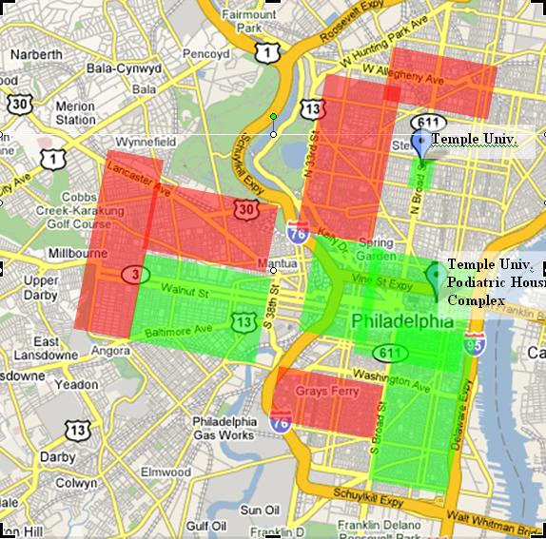
Grocery Recommendations:
This will really come down to going to whatever’s closest to where you live, but general suggestions have been made:

Chinatown.
Chinatown is in center city and has a lot of small markets and shops where you’ll find a lot of things not available in larger chain grocery stores. Prices are low here too.

Cookware can be found at low cost at Ross at 9th and Market Streets.

For people who prefer European food the following supermarkets are suggested:
Net Cost Market
11701 Bustleton Avenue
Philadelphia, PA 19116
Phone: (267) 672-2500 (map)

Bell's Market
8350-56 Bustleton Av.
PHILADELPHIA, PA
Phone: (215) 342-6016 (map)

Particularly for Lynnewood Garden’s leasers, there’s a very convenient shopping center – Shop Mall. Also there’s a ShopRite which is also not that far from the place.

