Modelling a Trading Scheme for Green House Gas Emissions from European Agriculture. A Comparative Analysis based on different Policy Options
Ignacio Pérez Domínguez, Wolfgang Britz and Karin Holm-Müller
Paper accepted for presentation at the at the EcoMod International Conference on
Energy and Environmental Modelling
Moscow, Russia (13 – 14 September 2007)

Abstract
A rational negotiation strategy for coming multilateral negotiations regarding climate change requires knowledge about possible social, economic and environmental effects of policy instruments for greenhouse gas emission abatement. With this purpose the existing CAPRI modelling framework for the European Agricultural Sector is expanded to cover greenhouse gas emissions from agricultural sources and policy instruments for their abatement. This modelling approach is based on the application of a permit trade scheme for emission abatement compared within the Kyoto Protocol ‘first commitment’ baseline. The effects derived of three alternative schemes are described in detail: the EU ‘burden sharing’ agreement option defined as regional standards, permit trade between regions inside each Member States, and finally, permit trade between regions at EU level. The analysis shows the importance of selecting an adequate combination of instruments of emission abatement for the design of efficient emission reduction policies.
Keywords: Kyoto Protocol, CAP Reform, agriculture, modelling, tradable permits

Modelling a Trading Scheme for Green House Gas Emissions from European Agriculture. A Comparative Analysis based on different Policy Options
Ignacio Pérez Domínguez, Wolfgang Britz and Karin Holm-Müller

Introduction: political background
In the current decade, the search for economically viable alternative energy sources has become the attention of many governmental and non-governmental institutions, mainly driven by an increase in consumption and raising prices of non-renewable energy sources. For instance, agricultural biomass has gained importance due to its potential to produce energy through combustion, fermentation or industrial processing. This public debate has brought the agricultural sector much closer to the energy sector and the political efforts on greenhouse gas (GHG) emission control. For instance, according to the EU biofuels directive 2003/30/EC, the EU Member States should ensure that biofuels and other renewable fuels attain a minimum share of total national consumption of transport fuel. The main advantage of the introduction of biofuels production is in terms of abated GHG emissions from fossil sources.
From a historical perspective, the control of global warming emissions in the EU can be divided in three regulatory phases beginning in the early 90’s. In December 1991 the European Commission presented to the Council a ‘community strategy to limit carbon dioxide emissions and to improve energy efficiency’, based on the premise that reducing energy demand by increasing energy efficiency and promoting fuel-switching was the best way to reduce CO₂ emissions (Commission of the European Communities 1992). Common action in this area was promoted through new research projects and programs in specific areas (automobile industry, energy and renewable products). Within the following two years, the European Union adopted a monitoring mechanism on anthropogenic CO₂ and other GHG emissions not controlled by the Montreal Protocol (Council of the European Communities, 1993, Dec. 1993/389/EEC) and approved the ‘ultimate objective’ of the UNFCCC (Council of the European Union, 1994, Dec. 94/69/EC). With these two documents, the main international agreements towards the reduction of GHG emissions were adopted by the European Community and its Member States. Additionally, the EU went somewhat further and, in 1996, launched a directive concerning integrated pollution prevention and control which laid down measures designed to prevent or reduce emissions in the air, water and land from certain polluting activities (Council of the European Union 1996, Dir. 96/61/EC). This directive defined a framework for pollution prevention and control through which emission permits could be issued. In 2000, in a second regulatory stage, the Commission approved the ECCP (European Climate Change Program) with the goal of identifying and developing all the necessary elements of a common strategy to implement the Kyoto Protocol (KP). It was based on two pillars, a Green Paper on emission trading and the development of targeted measures to reduce emissions from specific sources. The Green Paper on emission trading was published by the Commission as preparation for the ratification of the KP (Commission of the European Communities, 2000b). It was conceived to be an ‘informative’ and at the same time ‘analytical’ tool to support the future involvement of the Community in this area. Finally, in December 2002, the KP was formally approved by the European Union (Council of the European Union, 2002, Dec. 2002/358/EC). With this decision an important step towards action was reached. Member States committed themselves to establish a ‘European emission bubble’ (foreseen in the article 4 of the KP) by which the obligations contained in the KP for the EU were considered ‘internal law’ (article 3). In order to achieve this commitment, the European Union was allowed to formulate an internal ‘burden-sharing agreement’ (BSA) so that Member States would share their efforts towards the achievement of an overall emission abatement objective. This decision led to the signature in 2003 of the ‘emission trading directive’.
In October 2003 the EU adopted a proposal for a directive in ‘CO₂ emission trading’ to be operable by January 2005 (Council of the European Union, 2003, Dir. 2003/87/EC). This directive has established a scheme for trading GHG emission allowances within the EU in order to promote reductions of GHG emissions in a cost-effective and economically efficient manner (article 1). It applies to a list of energy and industrial production activities and covers all GHGs included in Annex A of the KP. Nevertheless, according to the categories of polluting activities defined in Annex 1 of this directive, only CO₂ emissions are effectively covered by the scheme. It defines a coordinated Emission Trading Scheme (ETS) over all Member States and foresees an implicit voluntary opt-in for other sectors through possible amendments (article 30). Whereas trading is first applied only to industrial and energy-producing activities, other sectors might be included in the future with a view to further improving the economic efficiency of the scheme. This is an important point with regard to the potential extension to the agricultural and forestry sectors.

Modelling Framework

CAPRI (basic features)
The CAPRI modelling system is a large-scale agricultural sector model with a focus on EU27, Norway and Western Balkans, but as well covering global trade with agricultural products. Developed since 1996, it is now used by different institutions including the European Commission for policy impact assessment. CAPRI is split into two major modules. The supply module consists of about 250 independent aggregate non-linear programming models representing all regional agricultural activities as defined by the Economic Accounts for Agriculture (EAA), each model representing the aggregate choices of farmers in a NUTS II region. Those models are a kind of hybrid approach, as they combine a Leontief-technology for intermediate inputs covering a low and high yield variant for the different production activities with a non-linear cost function which captures the effects of labour and capital on farmers’ decisions, combined with constraints relating to land availability, animal requirements, crop nutrient needs and policy restrictions (production quotas and set-aside restriction). The non-linear cost function allows for perfect calibration of the models and a smooth simulation response rooted in observed behaviour. The supply models feature a high differentiation in production activities (28 crop and 13 animal activities), capture in high detail the premiums paid under CAP and use an expected utility approach from stochastic revenues to model the complex sugar quota regime. The market module consists of a spatial, non-stochastic global multi-commodity model for about 40 primary and processed agricultural products, covering about 40 countries or country blocks in 18 trading blocks. Bi-lateral trade flows and attached prices are modelled based on the Armington assumption of quality differentiation. The behavioural functions for supply, feed, processing and human consumption in the market module apply flexible functional forms where calibration algorithms ensure full compliance with micro-economic theory. This module allows for market analysis at global, EU and national scale, including a welfare analysis
As the supply models are solved independently at fixed prices, the link between the supply and market modules is based on an iterative procedure. After each iteration, during which the supply module works with fixed prices, the constant terms of the behavioural functions for supply and feed demand of the market module are calibrated to the results of the regional aggregate programming models aggregated to Member State level. Solving the market module then delivers new prices. A weighted average of the prices from past iterations then defines the prices used in the next iteration of the supply module. Equally, in between iterations, CAP premiums are re-calculated to ensure compliance with national ceilings.
The specific structure of CAPRI renders is especially suitable for environmental analysis. In opposite to Computable General Equilibrium or Multi-commodity models, the regionalized programming models capture in detail links between agricultural production activities, and allow, based on the differentiated lists of production activities, inputs and outputs, to define environmental effects of agriculture in response to changes in the policy or market environment. They allow for the integration of different types of environmental policy instruments (standards, taxes, technical abatement options). In opposite to many other regionalized agricultural sector models, the transparent link with the large-scale global market model in CAPRI allow to capture price feedback for agricultural products. An own module for trade in young animals ensures a plausible mix of pig and cattle activities.

CAPRI Permit Trading module (methodological approach)
The modelling of tradable emission permits has been implemented in the CAPRI model in a separate module. That approach was deemed suitable as it required no structural changes in the overall systems, fits well to the existing modular approach of a transparent combination of different elements, and allows to a large extent an independent maintenance and further development of the different modules. Basically, besides modules dealing with markets for final agricultural products and young animals as already comprised in the system, a third market module for GHG emission permits was linked into the system, again using an iterative approach which updates permit prices and regional emission ceilings in between iterations.
Depending on the scenario selected, Nuts 2 regions are allowed to trade emission permits which each other and face different transaction costs depending on whether trade is taking place between national agents (within a Member State) or between agents across borders (within the EU-27). Moreover, additional costs for setting up the necessary institutions (fix transaction costs) are also included in the decision-taking process.
The new module consists of two elements. The first one adds a new constraint in the supply model which defines GHG emissions from agriculture at regional level according to the UNFCC (United Nations Framework on Climate Change) emission accounting scheme. By setting an upper bound on GHG emissions, effects of a standard or permit distribution for GHG emissions on agricultural supply and intermediate demand at regional level can be simulated, and the related marginal abatement costs derived as the shadow prices of the constraint. Clearly, the iterative feedback from the global market modules allows simulating impacts on demand, trade and prices of the emission ceiling. The second element consists of a permit trade module which, based on a second order approximation of the marginal abatement cost curve, defines market clearing prices for permits and the regional distribution of the permits.
In the permit trading module, interregional trade of permit allowances is simulated by maximising the total rent from trading under a constant sum of regional permits. At the market clearing point transaction costs should account for the remaining differences in regional permit prices, which should reflect the regional marginal abatement costs. For the modelled multi-regional case, the permit trading module is analytically constructed as a maximisation problem:
(2.) $\begin{aligned}\text{Max} \text{Obje}=\sum_{r}{[\frac{1}{2}}\left({\text{PermitP}}_{r}^{i}−{\text{PermitP}}_{r}^{f}\right)∗\left({\text{AllowP}}_{r}^{f}−{\text{AllowP}}_{r}^{i}\right) \\ +\left({\text{AllowP}}_{r}^{f}−{\text{AllowP}}_{r}^{i}\right)∗{\text{PermitP}}_{r}^{f} \\ −\left({\text{BuysIn}}_{r}+{\text{BuysOut}}_{r}\right)∗{\text{VarTC}}_{\text{Inst}} \\ −\left({\text{BuysIn}}_{r}∗\text{VarTCIn}+{\text{BuysOut}}_{r}∗\text{VarTCOut}\right)]\end{aligned}$
subject to several restrictions:
(2.) ${\text{AllowP}}_{r}^{f}={\text{AllowP}}_{r}^{i}+\left({\text{BuysIn}}_{r}+{\text{BuysOut}}_{r}\right)−\left({\text{SalesIn}}_{r}+{\text{SalesOut}}_{r}\right)$
(2.) $\sum_{r}{\left[{\text{SalesOut}}_{r}\right]}=\sum_{r}{\left[{\text{BuysOut}}_{r}\right]}$
(2.) $\sum_{r∈\text{MS}}{\left[{\text{SalesIn}}_{r}\right]}=\sum_{r∈\text{MS}}{\left[{\text{BuysIn}}_{r}\right]}$
(2.) ${\text{PermitP}}_{r}^{i}=α_{r}+β_{r}∗{\text{AllowP}}_{r}^{i}$
(2.) ${\text{PermitP}}_{r}^{f}=α_{r}+β_{r}∗{\text{AllowP}}_{r}^{f}$
Where:
Obje = welfare from emission trade
α, β = intercept and slope of the regional permit demand function
AllowP^{i} = initial distribution of permits (initial upper-bound imposed on emissions)
AllowP^{f} = final distribution of permits for the region (after trading)
PermitP^{i} = initial permit price (shadow price of the emission restriction)
PermitP^{f} = final permit price (after trading)
BuysIn = permits bought by region r from regions in the same Member State
BuysOut = permits bought by region r from regions in other Member States
SalesIn = permits sold by region r to regions in the same Member State)
SalesOut = permits sold by region r to regions in other Member States
VarTC_Inst = per unit transaction costs linked to the pre-implementation and implementation of the scheme (institutional transaction costs)
VarTCIn = per unit transaction costs directly linked to trade within the same Member State (e.g. brokerage fees)
VarTCOut = per unit transaction costs directly linked to trade with regions in other Member States (e.g. brokerage fees)
In the optimisation problem presented in equation (2.) the sum of the areas below the regional permit demand functions between the initial and the final market clearing situation is maximised. This is achieved by moving away from the initial permit distribution ${\text{AllowP}}_{r}^{i}$ to the final distribution ${\text{AllowP}}_{r}^{f}$. The area change below the permit demand functions is comprehended by the objective function and divided in two terms: a triangle ($0\text{.}5∗\left({\text{PermitP}}_{r}^{i}−{\text{PermitP}}_{r}^{f}\right)∗\left({\text{AllowP}}_{r}^{f}−{\text{AllowP}}_{r}^{i}\right)$) and a rectangle ($\left({\text{AllowP}}_{r}^{f}−{\text{AllowP}}_{r}^{i}\right)∗{\text{PermitP}}_{r}^{f}$). Variable transaction costs are chared to the permit buyers and are subtracted from the obtained rent.
The constraints of the problem are:
- Equation (2.): the total amount of permits allocated to a region in the market has to be equal to the initial allocation plus purchases and sales, inside and outside of the Member State.
- Equation (2.): total permit sales from regions in other the Member State has to be equal to total permit purchases from other Member States (international permit trade balance).
- Equation (2.): total permit sales and permit purchases between regions in the same Member State have to be equal (national permit trade balance).
- Equation (2.): the initial regional permit price lays on the permit demand function and is defined through the intercept, the slope and the initial permits allocated to the region.
- Equation (2.): the permit demand function has to pass through the simulated regional permit price, which is defined through the intercept, the slope and the new amount of permits allocated to the region.
This approach is analogous to a consumer rent maximisation problem: agricultural producers behave as consumers and demand permits according to their marginal willingness to pay given by the individual permit demand functions, which reflect the marginal profits attached to the Green House Gas emission constraint. With fixed prices for agricultural outputs, trade of emission allowances must lead to income gains or at least to no change in income in each region compared to a no-trade situation.
Given the structure of the non-linear programming models, there exists no closed-form representation of the marginal abatement cost curve. That is especially true under changing output prices which impact on the marginal abatement costs. Accordingly, only a second order approximation of the marginal abatement cost curves was implemented through linear permit demand functions, modelled to pass in each iteration through the initial regional permit price (${\text{PermitP}}_{r}^{i}$) which results from the application of the uniform regional emission standard at the starting point and that estimated in the final situation (${\text{PermitP}}_{r}^{f}$).
It is important to remember that the above discussed ‘emission trade model’ would deliver in just one step the optimal demand of permits per region and thus the optimal regional permit distribution (transaction costs considered) if the permit demand functions implemented in the permit trade module would correspond to the real regional MACCs (Marginal Abatement Cost Curves). For the reasons given above, instead an iterative approach is chosen.
During the first iteration, permit allowances are distributed to regions based on an equal percentage reduction of the GHG emissions in the baseline, and the shadow price on the emission ceiling derived by solving the regional models deliver one point on the regional MACC curve to which the permit trade models need to be calibrated. The permit trade module works during the first iteration with assumed slopes of the MACCs, as so far only one point of the MACC curve is known.
In the second and following iterations the information delivered by the trading module in the form of regional permit allowances (${\text{AllowP}}_{r}^{f}$)used in the regional supply models to update the emission ceilings in order to calculate an updated vector of shadow values. With this information intercepts and slopes for the permit demand functions can be estimated since at least two equilibrium points coming from the supply model (points on the real MACCs) are available. By doing so, the permit demand functions in the permit trade module are updated, and by solving the update module an updated vector of permit allowances and related prices generated to be used in the next iteration.
(2.) $β_{r}={\left(μ_{r}^{\text{step}−2}−μ_{r}^{\text{step}−1}\right)}/{\left({{\text{emission}}_{r}^{\text{step}−2}}/{{\text{emission}}_{r}^{\text{step}−1}}\right)}$
$α_{r}=μ_{r}^{\text{step}−1}−β_{r}∗{\text{emission}}_{r}^{\text{step}−1}$
The process is iteratively repeated until no noticeable price changes are observed between the results delivered by the supply model and the permit trading module for a vector of permit allowances (the value of the objective function of the permit trading module is at its maximum). At this stage, the final equilibrium is achieved.

Scenario construction

CAPRI Baseline
CAPRI combines in a unique way expert judgements and trend analysis to provide a scenario baseline, used as comparison point for counterfactual analysis. The baseline may be interpreted as a projection in time covering the most probable future development of the European agricultural sector under the status-quo policy and including all future changes already foreseen in the current legislation. Expert data on future trends are obtained from internationally reliable sources doing forecasting research at EU level (Commission of the European Communities) and for non-EU regions and exogenous drivers (FAO and World Bank). This information and own trend projections using time series from the current CAPRI database are fed into a Highest Posterior Density estimator which chooses the most likely combination of forecast value subject to a larger set a consistency restrictions which ensure mutual compatibility between the projected variables and plausibility of results (e.g. closed area and market balances, feed requirements, production quotas, set-aside restriction, composition of cattle herds).
Similar to Computable General Equilibrium models, calibration of the non-linear programming models is based on the definition of a parameter set fulfilling first-order conditions at the pre-defined baseline results, including both parameters of the non-linear costs function and technical coefficients. On the market side, the projection results at EU-27 level plus Norway and Western Balkans are taken as given for calibration. In the calibration step bilateral import and export flows from these countries to other trade blocks are defined, as well as development of agricultural production, feed use, processing activities and human consumption.
- Exogenous drivers considered for the baseline construction
Source: CAPRI Modelling System
The CAPRI Baseline explicitly comprehends all the changes foreseen in the Common Agricultural Policy until 2013.

Emission Restrictions
In this scenario block, an 8% emission reduction on GHG emissions from agriculture is analysed. This emission reduction target covers all EU27 Member States and is projected to happen in year 2013 (end of the first commitment period of the Kyoto Protocol) on top of the current legislation. In order to implement it, two policy options have been selected:
  - A regional homogeneous emission standard of 8% with respect to the baseline. This affects equally all European regions, so that no regional cost structures are considered in the determination of the emission reduction goal (see column 2 of Error: Reference source not found). The baseline emissions in CAPRI are calculated based on the 1996 IPCC emission coefficients, the nutrient content per activity and the projections responding to the most-likely development of the international agricultural markets (see column 1 of Error: Reference source not found).
  - In order to find a more suitable solution for balancing the burden of emission abatement, an ad-hoc burden sharing agreement for agriculture (BSAA) is proposed for the EU27, where percentage reductions differ between Member States, but are identical for regions inside the same Member State. The purpose is to analyse a regionally differentiated emission standard by building 4 clusters of Member States with different emission reduction targets (no change, -5%, -10% and -15%, see column 3 in Error: Reference source not found). This clustering is done by trying to close the gap to the actual marginal costs of abatement in the regions, derived from a hypothetical situation of perfect convergence of marginal costs through permit trade with no transaction costs (see column 4 in Error: Reference source not found). With this rationale, the efficiency of the policy measure in terms of welfare is increased.
- GHG emission in 2013, baseline and different scenario
Source: CAPRI Modelling System

Trade of emission permits
In this scenario block, the scenario analysis is enhanced by the explicit implementation of a European market of emission permits. With this purpose, information on transaction costs related to existing trading schemes is explicitly considered, since they are meant to have an important effect on the economic performance of such an instrument. Two policy implementation options are therefore considered:
  - Unrestricted emission trading. In this scenario, an 8% emission reduction target is enforced for all regions within the EU27 and trade is allowed between them. The original permit distribution is based on the emissions in the baseline minus 8%. Variable and fix transaction costs are introduced as additional marginal abatement costs. Variable transaction costs are mainly brokerage fees and are paid by permit buyers. In the current study, they are assumed to be 5 € per ton of CO2 equivalent for purchases within a Member State (trade with national agricultural producers) and 10 € per ton (?) for purchases from abroad (trade with foreign agricultural producers). These values are based on estimates from various studies which report handling fees in international trading schemes to be between 2 and 10 % of the transaction value (compilation by Eckermann et al. 2003, p. 16). For the selection of the ‘appropriate’ values in relation to the final permit price, a simple ‘sensitivity analysis’ for different values is carried out with the model. Moreover, a further 10 Mio € are assumed as institutional costs of the trading scheme (2 Mio € per year with 5 years amortisation). These are also assumed to be paid by permit buyers and therefore distributed over transactions. They are defined based on information found in the literature for CDM and JI projects in different economic sectors and project sizes (compilation by Eckermann et al. 2003, pp. 6-8)..
  - Restricted emission trading. . In this scenario, an 8% emission reduction target is enforced for all regions within the EU27 but trade is only allowed within national borders. The idea is to mimic existing trading schemes in the EU (e.g. different trading schemes of milk quotas). The original permit distribution remains the same as in the previous case.

Important aspects to consider in the scenario analysis
There are three effects which are not covered in the current analysis worth to be mentioned. Firstly, the abatement analysed in here is related strictly to agricultural direct emissions and does not cover indirect ones like e.g. emissions from fertilizer production. Secondly, the analysis does only take into account GHG emissions in EU27, so that changes in production in other parts of the world used to substitute reduced EU production, visible e.g. in increased EU imports of agricultural products, are not taken into account. And last not least, abatement is in here mostly related to changes in the farm production program, and not in improved process management. It hence builds on a rather simple and straightforward emission accounting scheme and not on on-farm measurements of emissions or more elaborated emission coefficients depending on single processes (e.g. how manure is spread). However, given the high numbers of agents involved, the high control and administration costs to include in Pan-European Legislation such a complex emission accounting scheme may render our solution more suitable for agriculture (opt-in solution for agriculture, so that farmers or groups of farmers can take part in the climate control schemes based on a rather simple accounting scheme.

Selected Results
In the following figure, the regional abatement costs attached to the imposition of a regional homogeneous emission standard of 8% with respect to the baseline are presented.
- Marginal abatement costs with a emission standard (in 1000 € per tonne of CO2eq)
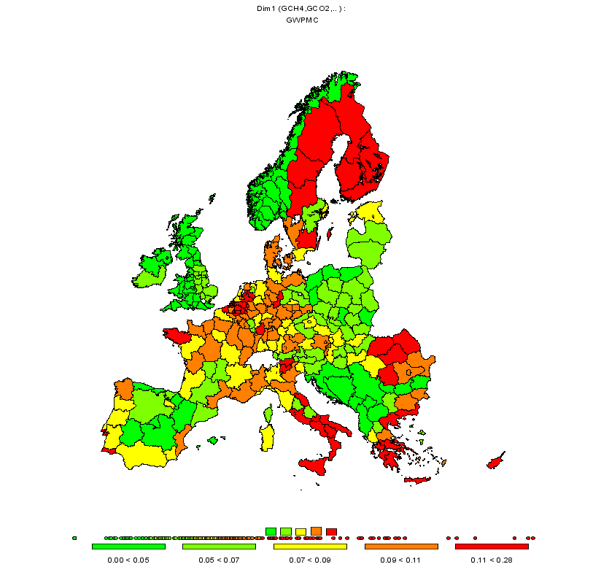
Source: CAPRI Modelling System; projection to year 2013
With a homogeneous emission standard at a regional level, the average marginal abatement cost for the EU27 is 95 Euro/tonne of CO2-equivalent. The regional costs vary between 30 and 280 Euro/tonne of CO2-equivalent

- Marginal abatement costs with a burden sharing agreement for agriculture (in 1000 € per tonne of CO2eq)
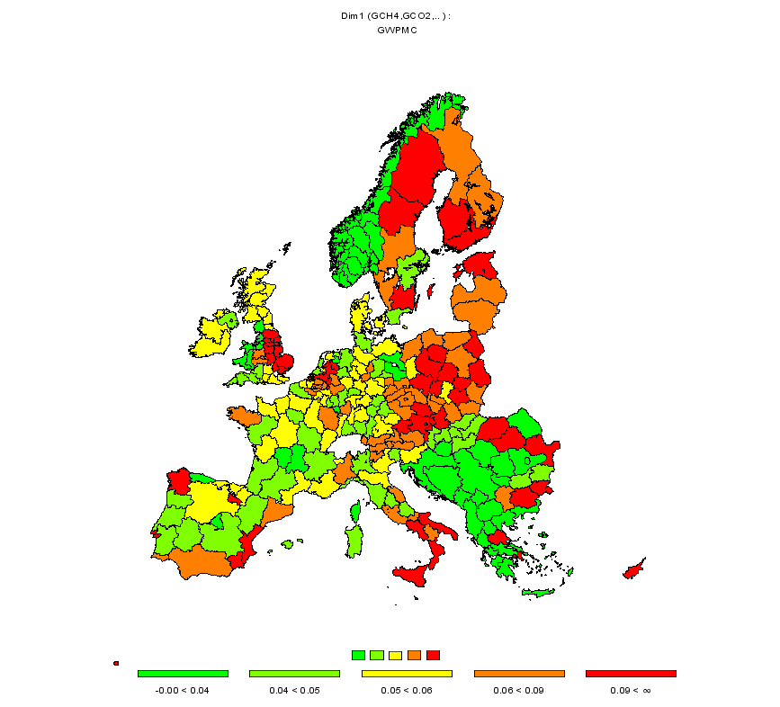
Source: CAPRI Modelling System; projection to year 2013
With a burden sharing agreement at a Member State level (see Error: Reference source not found), the average marginal abatement cost for the EU27 drops to 77 Euro/tonne of CO2-equivalent. The regional variation in marginal abatement costs is reduced with respect to the previous case.
- Evolution of regional permit prices under different trade schemes
Source: CAPRI Modelling System
If permit trading is introduced, the average marginal cost for the abatement of a CO2-equivalent emission varies in the EU27 varies between 73 Euro (in the case of no transaction costs), and 89 Euro in the case of intra-national trade. In the previous table, the convergence of prices at Member State level is presented. This is achieved after several iterations and with the consideration of endogenous market prices for agricultural products.
- Purchases of emission permits at the regional level with unrestricted trade (trade of permits allowed across Member State borders) (in 1000 units per tonne of CO2eq)
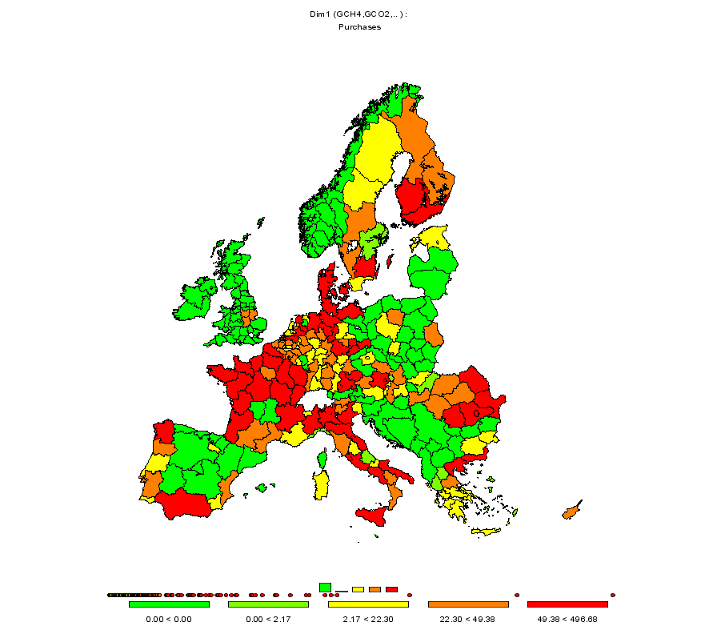
Source: CAPRI Modelling System;
If emission trading is introduced under explicit consideration of transaction costs, the purchases and sales of permits go up to 8.2 Mio Tonnes of CO2 equivalents. Of this amount, around 90% of the purchases come from abroad and 10% due to trade within national borders, which is mainly explained by the higher differences in marginal abatement costs between different Member States. As shown in Map (3) most of the regions in France, Benelux and Italy are a net permit buyers, whereas Eastern European regions are permit providers (due to the lower marginal abatement costs).
This picture changes when permit trade is restricted and only agricultural producers within a Member State are allowed to trade (see Map (4)). In this case only 3.2 Mio Tonnes of CO2 equivalents are traded, what also leads to a much less smooth convergence of permit prices between regions (see column 3 in table 3.
- Purchases of emission permits at the regional level with restricted trade (trade of permits only allowed within Member State borders) (in units per tonne of CO2eq)
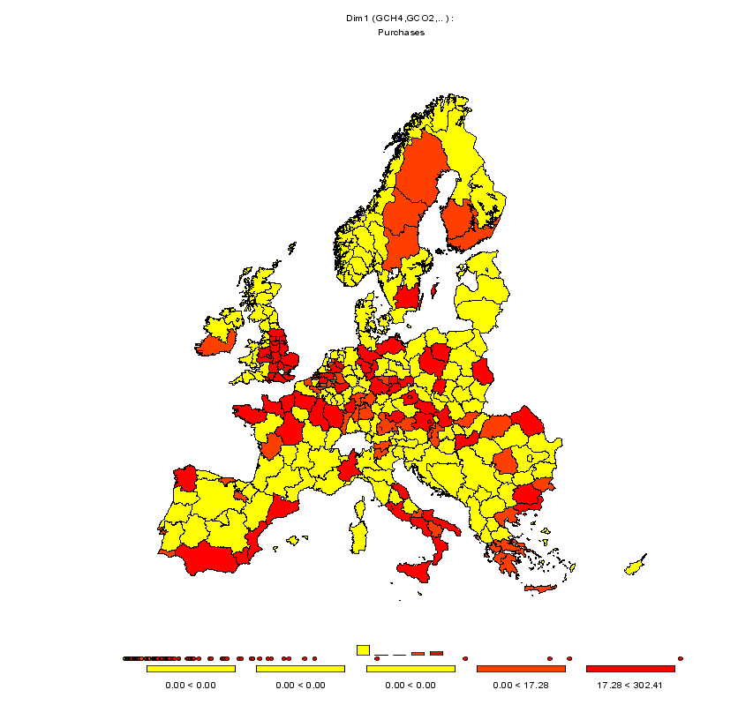
Source: CAPRI Modelling System;

Policy Recommendations
In this paper a EU-wide trading scheme of GHG emission permits from agriculture is proposed. The characteristics are: (1) coverage of EU27, (2) distribution of permits between agricultural producers free of charge and linked to historical emission records (grandfathering), (3) regional emission trading at Nuts 2 level only within each country (restricted trade) or also across Member State borders (unrestricted trade), (4) explicit consideration of transaction costs and (5) no enforcement penalties.
Moreover, a burden sharing agreement between the EU27 Member in order to meet a certain target for agricultural GHG emissions in 2013 at EU27 level is explicitly simulated, i.e. different emission reduction rates per country. Such an agreement already exists at for the EU at economy wide-scale. However, in this case a burden sharing agreement is proposed in order to be efficient from a welfare maximisation perspective, i.e. the agreed upon country specific reduction should take into the country specific abatement costs. It is however necessary to recognize that in practice, other aspects such as “fairness” (e.g. regarding chances for economic growth for the poorer Member States) and historical events (e.g. different industrialization processes in Eastern European countries) play an important role in finding such a political agreement. This quantitative analysis tries to feed some more rational into the policy-making process, as it explicitly considers a distribution of welfare changes across Member States, sectors and agents.
The current analysis sheds light on three different aspects of the GHG abatement debate. The first one adds an agricultural perspective to the general discussion. It has been shown that at least when applying a rather simple accounting scheme, abatement costs in agriculture are in a similar or even higher magnitude than in other sectors (70-90€ per tonne of CO2-equivalent for an 8% emission reduction). The analysis adds also to the discussion on bio-energy production, highlighting that agriculture itself is a direct and indirect In this paper a EU-wide trading scheme of GHG emission permits from agriculture is proposed. The characteristics are: (1) coverage of EU27, (2) distribution of permits between agricultural producers free of charge and linked to historical emission records (grandfathering), (3) regional emission trading at Nuts 2 level only within each country (restricted trade) or also across Member State borders (unrestricted trade), (4) explicit consideration of transaction costs and (5) no enforcement penalties.
Moreover, a burden sharing agreement between the EU27 Member in order to meet a certain target for agricultural GHG emissions in 2013 at EU27 level is explicitly simulated, i.e. different emission reduction rates per country. Such an agreement already exists at for the EU at economy wide-scale. However, in this case a burden sharing agreement is proposed in order to be efficient from a welfare maximisation perspective, i.e. the agreed upon country specific reduction should take into the country specific abatement costs. It is however necessary to recognize that in practice, other aspects such as “fairness” (e.g. regarding chances for economic growth for the poorer Member States) and historical events (e.g. different industrialization processes in Eastern European countries) play an important role in finding such a political agreement. This quantitative analysis tries to feed some more rational into the policy-making process, as it explicitly considers a distribution of welfare changes across Member States, sectors and agents.
The current analysis sheds light on three different aspects of the GHG abatement debate. The first one adds an agricultural perspective to the general discussion. It has been shown that at least when applying a rather simple accounting scheme, abatement costs in agriculture are in a similar or even higher magnitude than in other sectors (70-90€ per tonne of CO2-equivalent for an 8% emission reduction). The analysis adds also to the discussion on bio-energy production, highlighting that agriculture itself is a direct and indirect source of GWP emissions. The second important aspect is that of economic consequences of including agriculture in GHG abatement. Given in many cases prohibitive MFN tariffs for agricultural and food products, environmental legislation forcing large-scale reduction of agricultural production in Europe leads to sizeable price increases for agricultural products, given their low demand elasticities. That allows agriculture not only to carry over to a large extent increased production costs to the final consumer, but introduces a kind of monopolistic rent for the agricultural sector as a whole, as the agricultural GHG emission ceiling acts as a kind of supply control instrument. Even if the effect may be dampened at the rather high world prices for agricultural products right now, where the EU border protection is not longer such a definitive factor, it should it render attractive to include agriculture in GHG emission strategies as long as supporting farming income is still a major policy objective of the CAP. Politicians should however also be aware of the fact that indirectly increasing the food bill of the consumer by environmental legislation puts in percentage term a higher burden on the poorer part of the population where the budget share of food is higher.
The third aspect relates to implementation issues. Whereas there is no doubt that market solutions are superior to standards in a word without implementation costs, the picture is far less clear when public and private implementation costs come into play. For the analysis at hand, it is obvious that the control costs for the two options standards or permit trade would be probably rather similar: crop shares, animal herds and fertilizer sales would need to be monitored at farm level. However, if the differences in per unit abatement costs between the agents are close to the unitary costs of implementing and controlling the market – public and private ones -, the welfare gains will be reduced. The lesson from that is that policy support requires appropriate quantitative instruments to avoid overoptimistic advice based on text-book wisdom.

References
Britz, W. (ed.) (2005). CAPRI Modelling System Documentation, University of Bonn.
Britz, W., Heckelei, T., Pérez, I. (2006). Effects of Decoupling on Land Use: An EU wide, regionally differentiated Analysis, Agrarwirtschaft 55 (2006), Heft 5/6
Coase, R. (1937) The Nature of the Firm, in Economica, New Series (4), pp.386-405.
Commission of the European Communities (1992) Community strategy to limit carbon dioxide emissions and to improve energy efficiency, COM(92) 246 final, Brussels.
Council of the European Communities (1993) Council Decision 1993/389/EEC for a monitoring mechanism of Community CO2 and other greenhouse gas emissions, Official Journal of the European Communities, OJ L167.
Council of the European Union (1994) Council Decision 94/69/EC concerning the conclusion of the United Nations Framework Convention on Climate Change, Official Journal of the European Union, L033.
Council of the European Union (1996) Council Directive 96/61/EC concerning integrated pollution prevention and control (IPPC), Official Journal of the European Communities, L257.
Council of the European Union (2002) Council Decision 2002/358/EC concerning the approval, on behalf of the European Community, of the Kyoto Protocol to the United Nations Framework Convention on Climate Change and the joint fulfilment of commitments there under, Official Journal of the European Communities, L130.
Council of the European Union (2003) Council Directive 2003/87/EC establishing a scheme for greenhouse gas emission allowance trading within the Community and amending Council Directive 96/61/EC, Official Journal of the European Communities, L275.
Commission of the European Communities (2005). Prospects for Agricultural Markets and Income 2005-2012 - Update for EU Markets, Directorate-General for Agriculture, Brussels.
Eckermann, F., Hunt, A., Stronzik, M. and Taylor, T. (2003) The role of transaction costs and risk premia in the determination of climate change policy responses, Diskussionspapier No. 03-59, Zentrum für Europäische Wirtschaftsforschung, pp. 28.
FAO (2003) World agriculture: towards 2015/2030. A FAO perspective, Food and Agriculture Organisation, ISBN 92 5 104835 5 (FAO paperback), Rome.
IPCC (1997) Revised 1996 IPCC Guidelines for National Greenhouse Gas Inventories, Workbook and Reference Manual, Paris.
Massot Martí, A. (2005). Hacia una nueva PAC: Condicionantes para los Mercados de Materias Primas, ASFAC - IV Seminario de análisis de mercados de materias primas, Barcelona.
Pérez, I. (2006). Greenhouse Gases: Inventories, Abatement Costs and Markets for Emission Permits in European Agriculture. European University Studies, Series V: Economics and Management 213 pp. Peter Lang.
PriceWaterhouseCoopers (2000) A Bussiness View on Key Issues Relating to Kyoto Mechanisms, London.

Institute for Prospective Technological Studies (IPTS), Joint Research Center of the European Commission (Seville, Spain)
Institute for Environmental Sustainability (IES), Joint Research Center of the European Commission (Ispra, Italy)
Institute for Food and Resource Economics (ILR), Bonn University (Bonn, Germany)
This decision was first amended by Dec. 1999/296/EC (Council of the European Union, 1999) and further on replaced by Dec. 280/2004/EC (Council of the European Union, 2004a), ‘in order to take account of the developments on the international level and on the grounds of clarity’.
The approval of the BSA by the Member States reflects the ‘subsidiary principle’ in the Community, i.e. individual emission reduction objectives should be achievable for each country and avoid unduly burdening of ongoing industrialization efforts by Member States. The Council agreed upon the specific contributions of each Member State to the overall 8% reduction commitment at its meeting of Environment Ministers of 15-16 June 1998 in Cardiff (Commission of the European Communities, 2001, p. 3). The Council Conclusions set out the commitment of each Member State and state that the terms of this agreement will be included in the Council Decision on the approval of the Protocol by the European Community.
The list of activities included in annex I of the directive might be subject to future revision.
For a more detailed description of the modeling system see CAPRI Documentation (Britz, 2005).
It is considered realistic to assume lower transaction costs in the first case since trade between emitters ‘within a country’ is comparably cheaper in terms of the administrative burden.
In the absence of transaction costs a uniform permit price for all regions would be achieved at the optimum (equi-marginality principle).
Transaction costs are those costs that arise from initiating and completing transactions, such as finding partners, holding negotiations, consulting with lawyers or other experts, monitoring agreements, etc. (Coase, 1937).
The reader should be aware of the fact that the initial distribution of the permits impacts on the final distribution if transaction costs are taken into account, so that the Coarse Theorem may not longer holds. The Coarse theorem says that the parties can achieve the social optimum if the transaction cost is low, property rights clearly defined and enforced and everyone has full information.
As included in paragraph 4 of the official reporting to the UNFCCC by Member States.
The accounting of emissions is done by following the IPCC 1996 revised Guidelines (IPCC 1997)
Slight differences in total abatement are due to the fact that some regions became infeasible during iterations, so that the ceiling implemented in the programming model did not perfectly reflect allocation generated by the permit trade module

